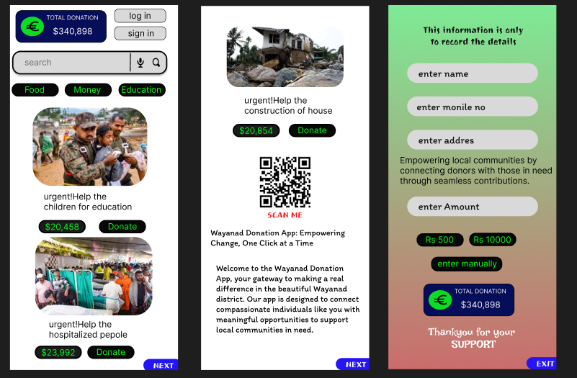The Wayand Donation App is a thoughtfully designed platform aimed at simplifying the donation process. Created with a user-centered approach in Figma, the app features an intuitive interface that allows users to easily navigate through various donation options, track their contributions, and engage with causes they care about. The design emphasizes accessibility, ensuring that users of all ages and technical proficiency can effortlessly participate. The color palette and typography are chosen to evoke trust and compassion, making the donation experience both seamless and impactful.

